1.Data :-
1.It’s collection of raw bytes.
Ex-Image , audio, video ,Integer all are collection of bytes.
2.data can be recorded and does not have a meaning unless process.
3.data is measured in bit and bytes.
2.Types of Data :
a)quantitative data.
1)Numerical form
2)Weight, volume, cost of item are quantitative data.
b)qualitative data :
1)Descriptive but not numerical.
2)Name, Gender, hair color of a person.
Ex:-we want to start our own business. So marketing company post our business on Facebook, insta, Linkdin.
And suppose 8 Likes are come from facebook.800 Likes are come from Insta. And 2 Likes are come from Linkdin.
So by this data we conclude. We have to post our business on insta.
What is data :-
Count of likes(in the form of integer). We process this data and conclude max likes on Insta.this is information.
E.g.,you have data of all the people living in your locality, its Data, when you analyze and interpret the data and come to some conclusion that:
i. There are 100 senior citizens.
ii. The sex ratio is 1.1.
iii. Newborn babies are 100.
These are information.
Diffrence b/w data and information :-
1.data is raw and unorganized, information is organized.
2.data does’t depend on information. However information depends on data.
3.data typically come in the form of graph,number
Figures or statistic. Information is typically presented through world language thoughts and ideas.
4.data is not sufficient for decision making , but you can
Make decision based on information.
5.data own it’s own is meaningless. When it’s analyzed and interpreate. It become meaningful information.
Data is very useful for developing our business :-
Suppose two person open restro. Person A have feedback system. But person B have no any feedback system. Person A have feedback system . so person A know which food are most sell and which food are not sell. So those food which is not sell. He can’t buy raw material for that but person B buy . so person B go in loss. So data is very important for developing our business.
What is Database?
Database is an electronic place/system where data is stored in a way that it can be easily accessed, managed, and updated.
What is DBMS?
A database-management system (DBMS) is a collection of interrelated data and a set of programs to access those data. The primary goal of a DBMS is to provide a way to store and retrieve database information that is both convenient and efficient.
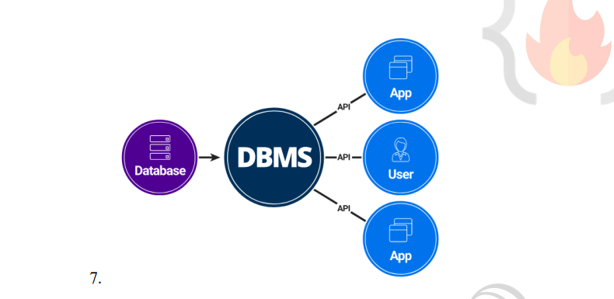

8. DBMS vs File Systems
a. File-processing systems has major disadvantages.
i. Data Redundancy and inconsistency
ii. Difficulty in accessing data
iii. Data isolation
iv. Integrity problems
v. Atomicity problems
vi. Concurrent-access anomalies
vii. Security problems
b. Above 7 are also the Advantages of DBMS (answer to “Why to use DBMS?”)

